**Controlling Deployments – Gates Activity # 6**

**20K-0409 Mukand**

**After creating project**

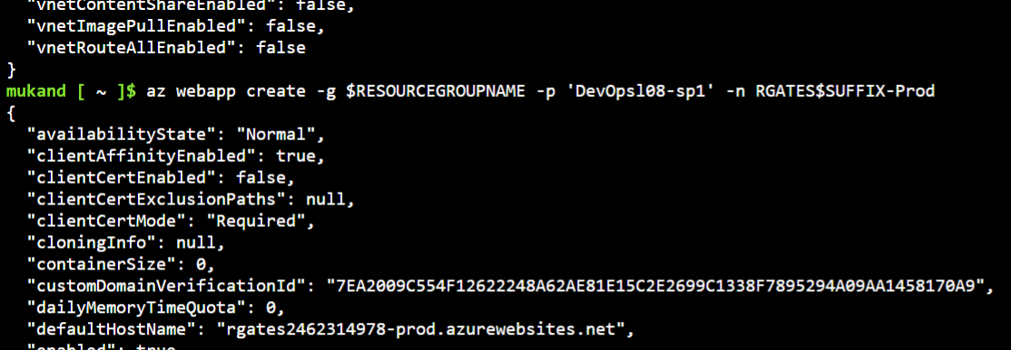

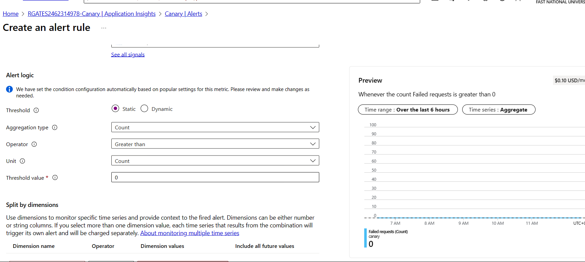

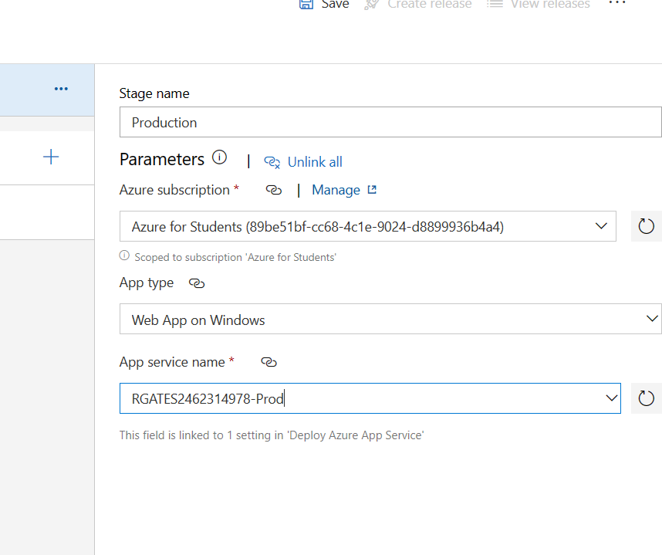

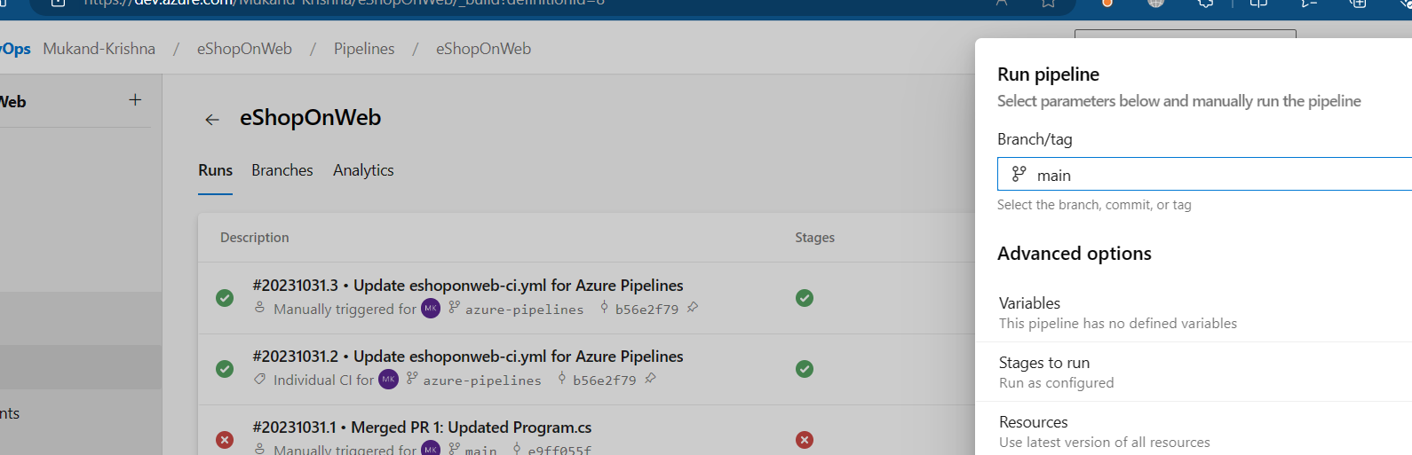

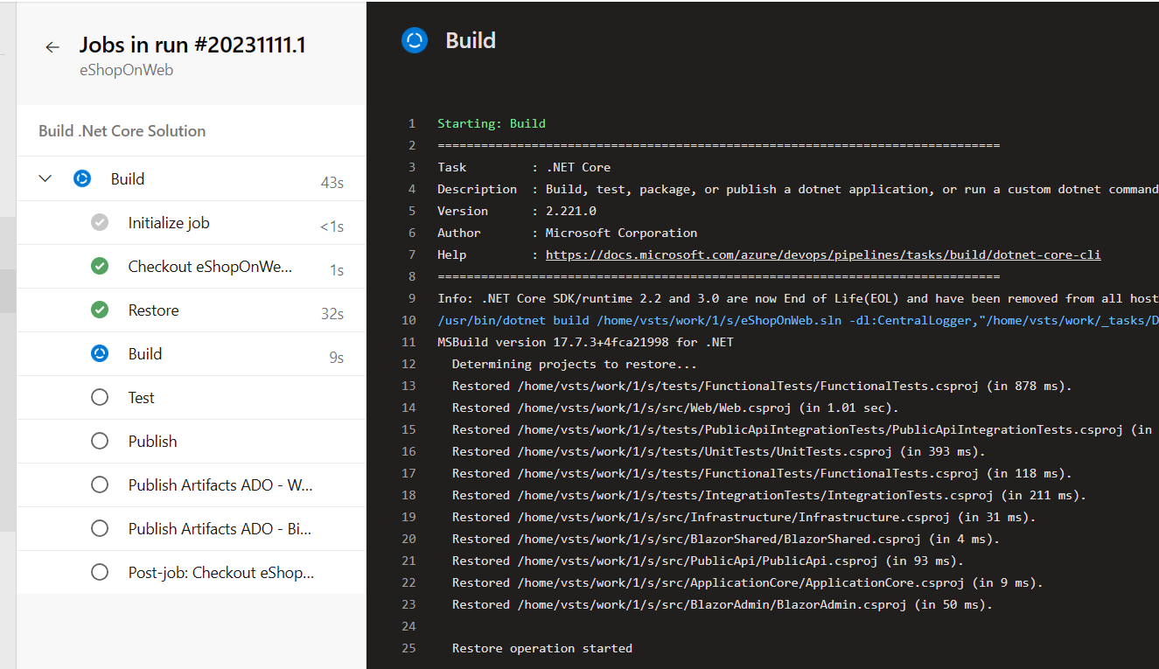

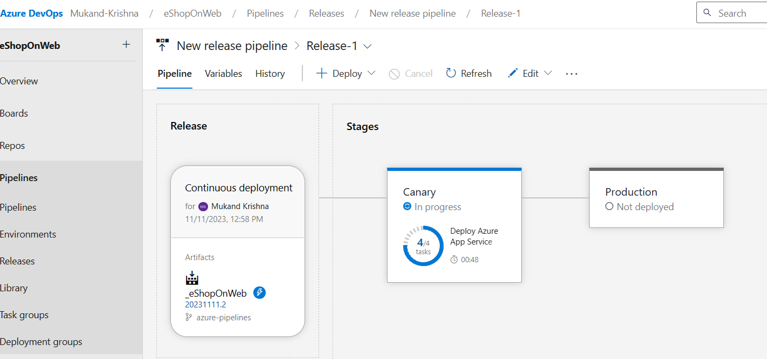

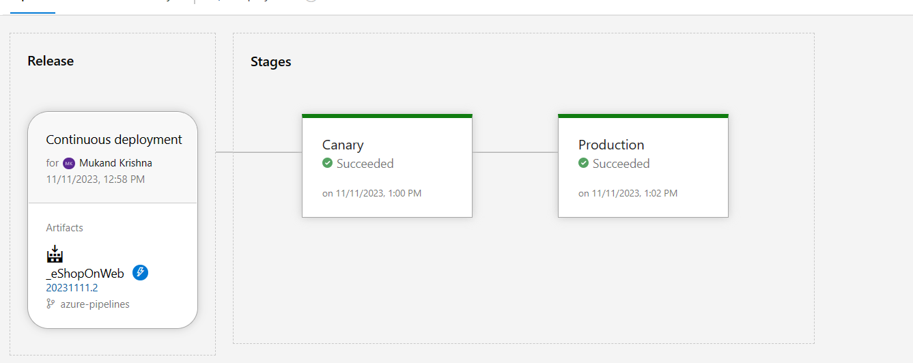

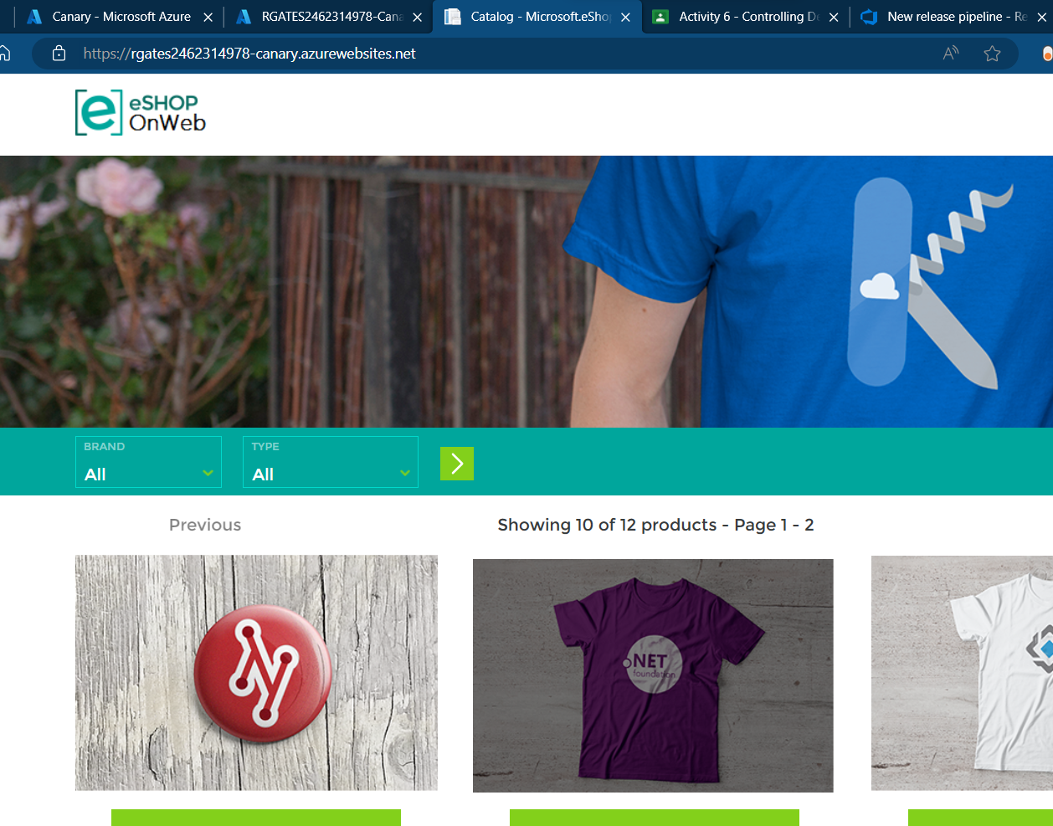

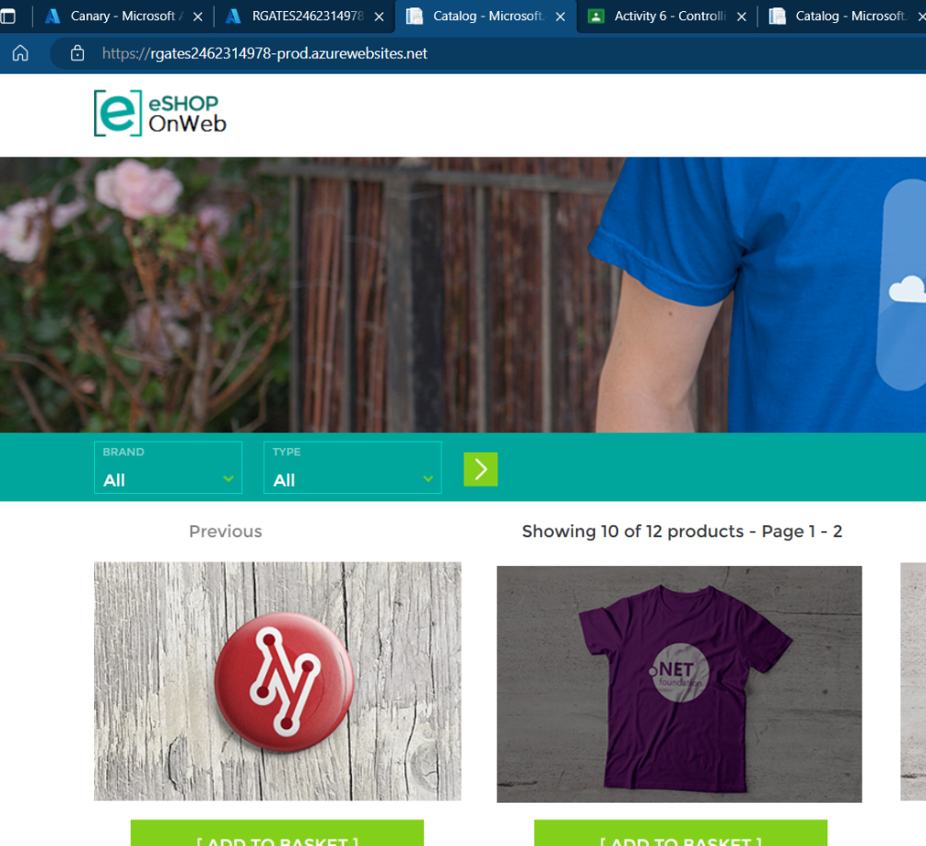

**Exercise # 4**

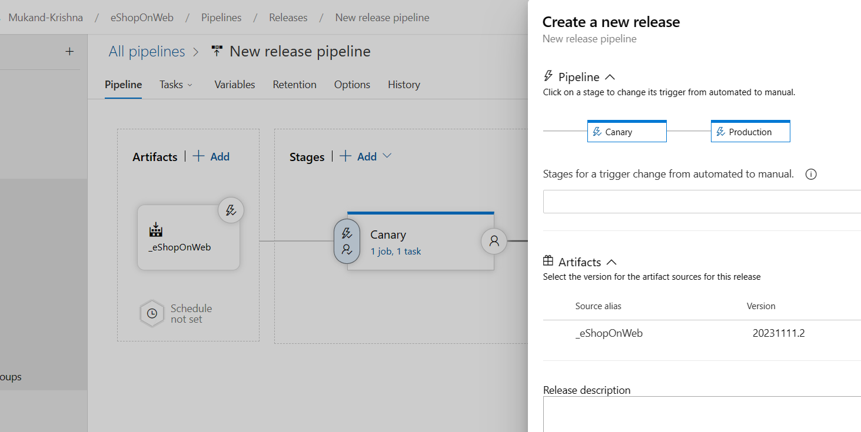

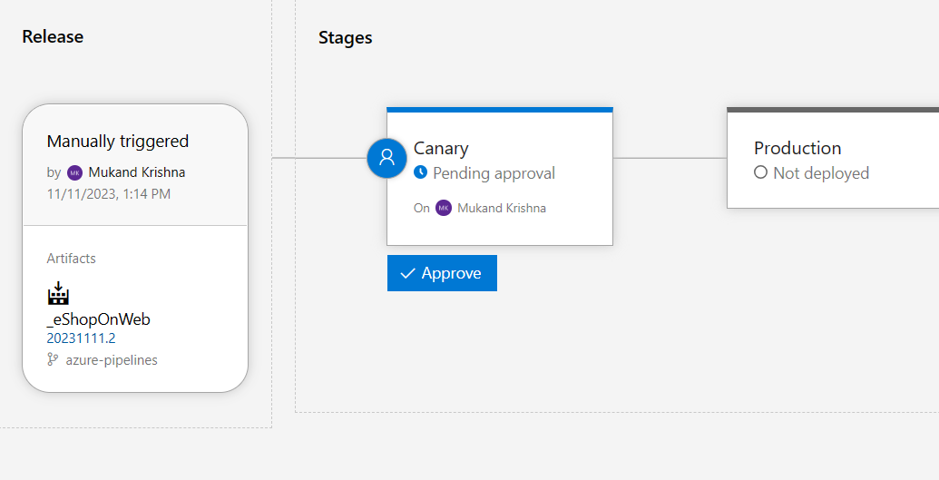

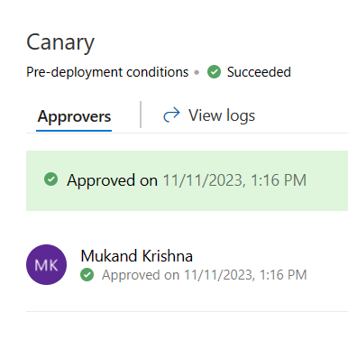

**Task 2: Configure post-deployment gates for Azure Monitor**

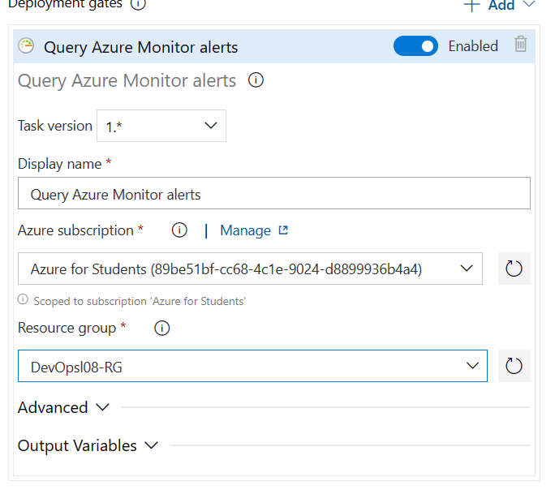

**Exercise 5: Test release gates**

**Task 1: Update and deploy application after adding release gates**

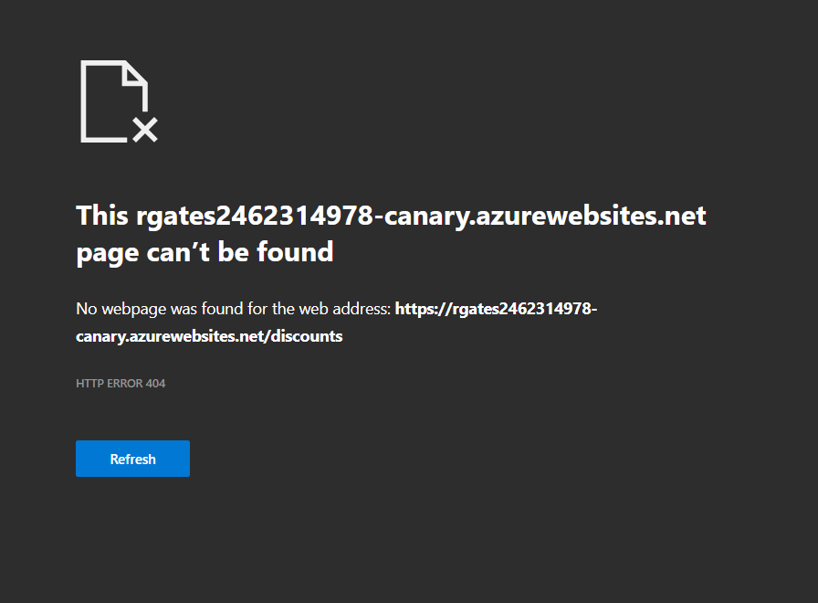

**6. Notice there should be at least 1 Failed_Alert** with Severity 2 -Warning showing up in the list. This got trigger when you validated the non- existing website URL address in the previous exercise.**

**\*\* Note:** If no Alert shows up yet, wait another few minutes.**

**Waited, refreshed etc., but wasn’t showing any warning.**

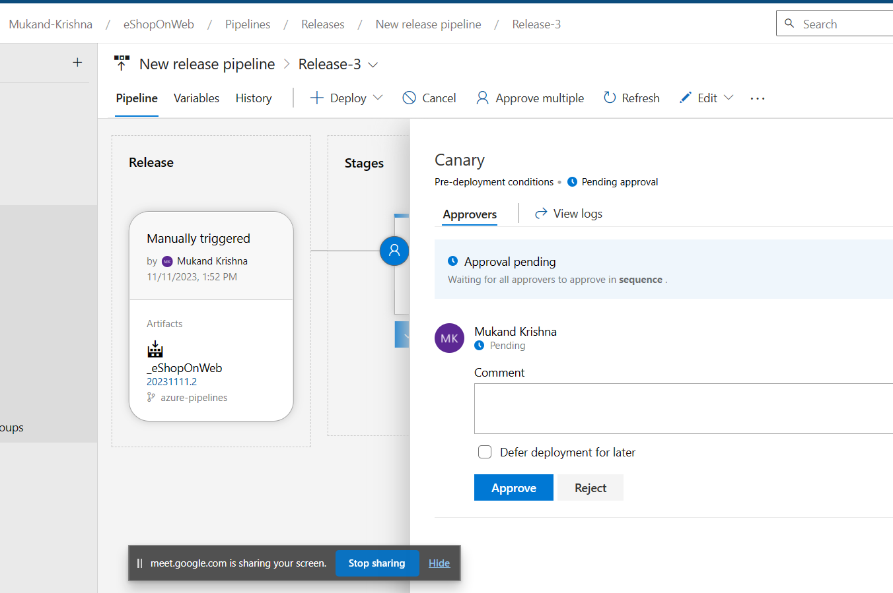

**Exercise 6: Remove the Azure lab resources.**



